COMPUTER NETWORKS LAB 08
University of Azad Jammu & Kashmir

Course: Computer Networks
Course code: (CS-2203)
Roll no :2024-SE-33
Name: Momina Imran
Submitted to : Asma Javed

Objective
MAC address table, and supports communication between hosts using ARP.
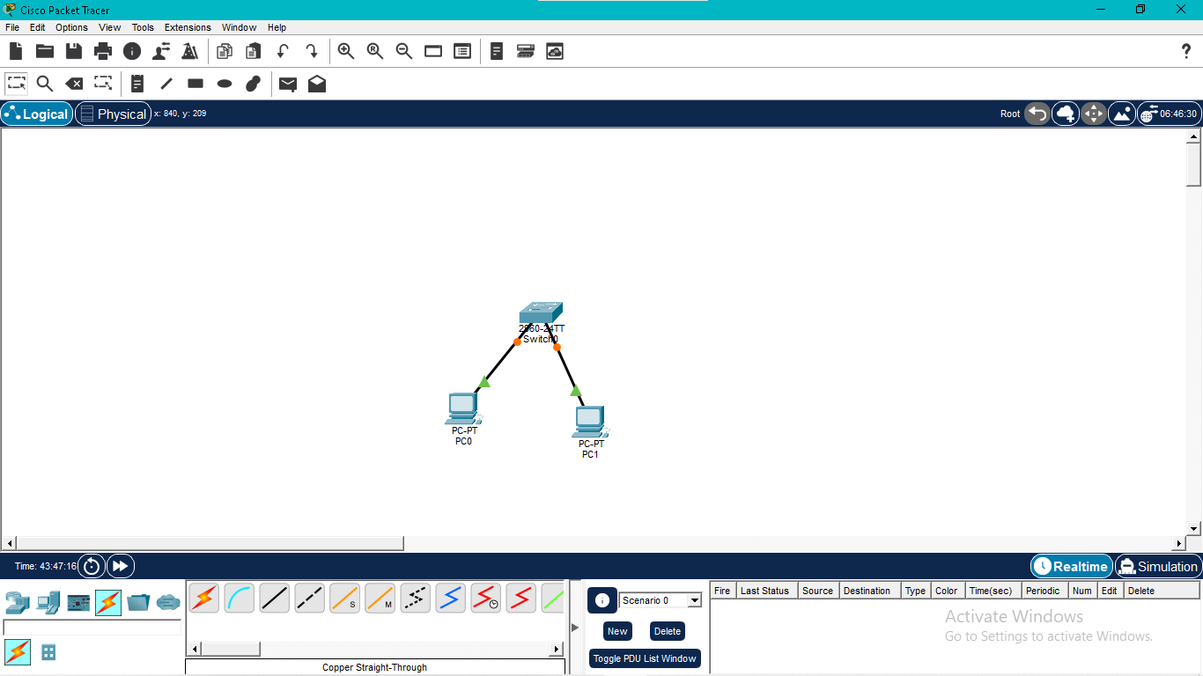
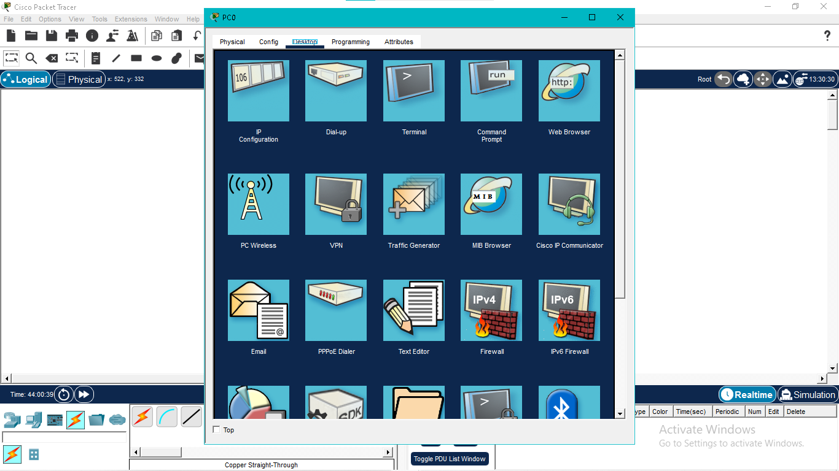

Activity 1: Building the Network Topology
A simple LAN was designed in Cisco Packet Tracer by connecting two computers to a single switch with copper straight-through cables. This setup provides a controlled environment to observe frame forwarding an address learning.
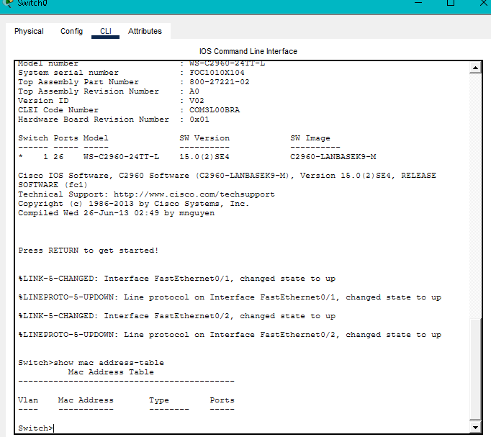

Activity 2: Inspecting the MAC Address Table
Before transmitting any data, the switch MAC address table was examined. Since no frames had been exchanged, the table contained no dynamically learned entries.
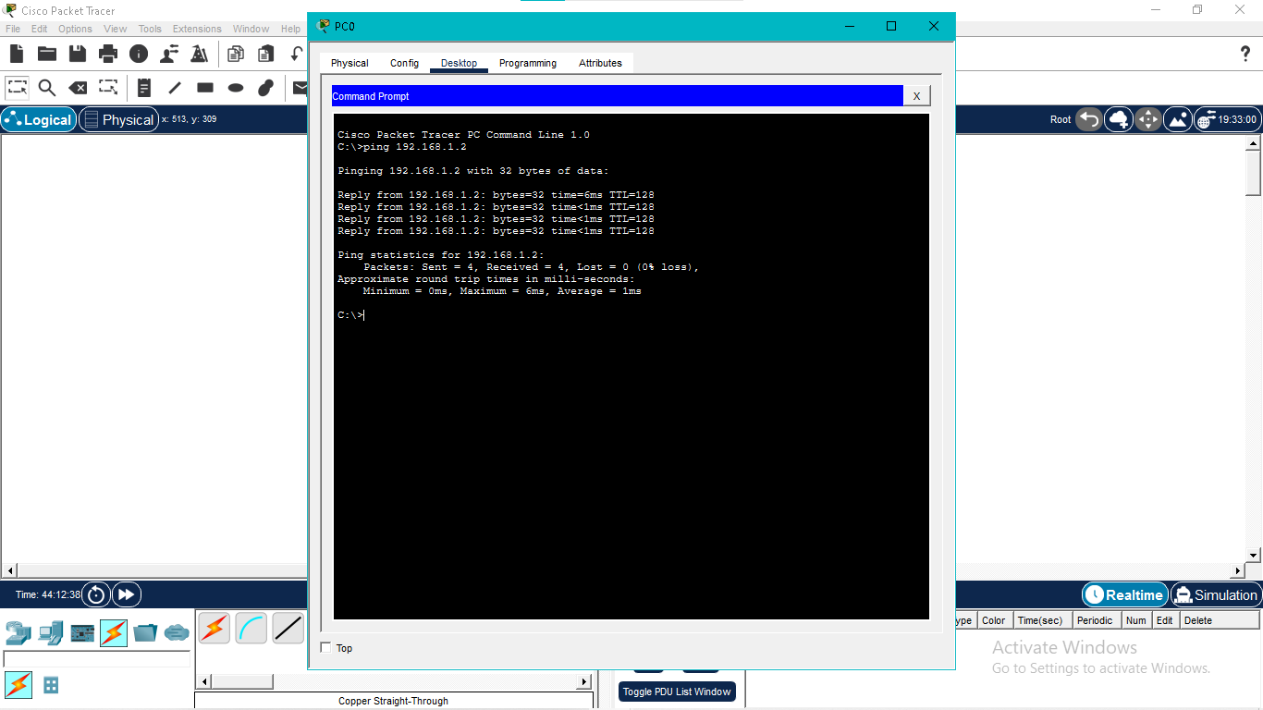

Activity 3: Testing Connectivity
An ICMP ping was sent from one PC to the other. During this process, ARP resolved the destination IP address into its corresponding MAC address, allowing successful communication between both hosts.
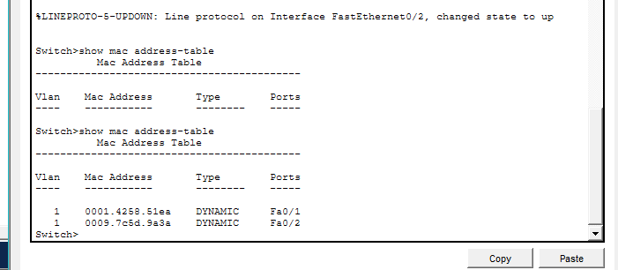

Activity 4: Verifying Dynamic Learning
After the ping test, the MAC address table was checked again. The switch had automatically recorded the MAC addresses of both computers and associated them with the correct switch ports.

Activity 5: Removing Learned Entries
The dynamic MAC table was cleared using the appropriate Cisco IOS command. A final verification confirmed that all learned entries had been removed from the switch.
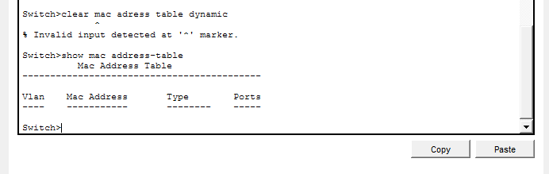

Conclusion
This exercise demonstrated the working principles of Layer 2 switching. It highlighted how ARP supports communication, how switches dynamically learn MAC addresses, and how the forwarding table can be viewed and managed through Cisco IOS commands.

